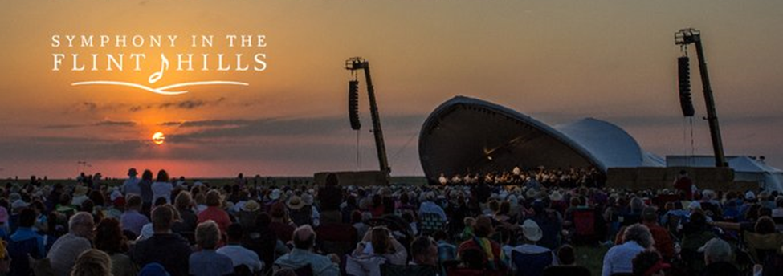
RAFFLE WINNER
CONGRATULATIONS
to
Pam Nowak
of the
Russell Sunrise Club
Pam lives in Gorham KS.

Pam is the Raffle Winner
receiving TWO Tickets
to the 17th Annual Performance
of the World Class Kansas City Symphony in the Flint Hills.
“Weather in the Flint Hills” will take place
at Irma’s Pasture in Chase County
on June 11, 2022.

CONGRATULATIONS, PAM!!!
Thank you to all who purchased tickets & support the Kansas Kiwanis Foundation!

